Accommodation
BaltSilica 2018 conference will be held in the Faculty of Materials Science and Applied Chemistry, Paula Valdena Street 3, Riga, on Kipsala island. Kipsala is an island in the center of Riga, on the left bank of Daugava river. It is located only a brief 15 min walk from Old Town Riga.
The conference fee does not include accommodation.
Closest Hotels to the Venue:
- 1,2 km to Venue: OK Hotel is a tourist and business class hotel, located in Pardaugava at Slokas 12 - not far from the tourist favourite streets of old Riga, the largest exhibition centre BT-1 at Kipsala, the international airport, railway station and sea passenger terminal.
1 twin room available (114+ eur for 2 nights), 1 triple room (101+ eur for 2 nights) and 1 quadruple room (130+ eur for 2 nights).
More information available on website: http://www.okhotel.lv/en/hotel.html
- 0,5 km to Venue: Hotel Vantis is located in an exclusive area of Riga - Kipsala island, so you can combine two opposites - life in the city centre and silence in suburban area.
6 twin and 5 double rooms available with the option of adding an extra bed in 6 of them. For 2 nights (breakfast included): 1 person – 50 eur, 2 persons – 60 eur, 3 persons – 85 eur.
More information available on website: http://www.hotelvantis.lv/en/home
- 0,5 km to Venue: Ķīpsala Campus Dormitory is located on Kipsala campus providing people with the advantage of being close to both Riga Technical University Faculty buildings and city centre. To make reservations at Riga Technical University students’ hostel, please write to: baltsilica2018@gmail.com
4 twin rooms available. For 2 nights: 1 person – 48 eur, 2 persons – 66 eur. NOTE: there are also several studio (5) and apartment (3) type rooms available for lecturers. For 2 nights: For studio apartment: 1 person – 80 eur, 2 persons – 100 eur, 3 persons – 146 eur; for regular apartment: 1 person – 110 eur, 2 persons – 140 eur.
- 0,9 km to Venue: Bridge Hotel is located just on the other side of Zundas channel which separates Kipsala island from the main part of Rigas left part.
1 single, 1 twin and 1 double room available. For 2 nights: single – 47 eur; twin – 48 eur; double – 48 eur.
- 1,8 km to Venue: located just on the other side of Daugava river Riga Centre Hotel E2 offers highly affordable prices and the ability to be within shouting distance of Old Riga as well as Kipsala island.
2 double bed rooms available – one for 60 eur, the other – 70 eur (for 2 nights).
- Hotel Laine is a RTU backed hotel located near the National Art Museum and just a 15-20 min walk or 10 min bus ride from the venue.
10 rooms available with twin beds. For 2 nights: 1 person – 45 eur, 2 persons – 60 eur.

To find more hotels in Riga visit: http://www.hotels.com/, http://www.tripadvisor.com/ or http://www.booking.com/

How to get to Riga?
Riga is easy to reach to travellers from both West and East. Choose what transport suits you best – a plane, train, bus, car, or a ferry across the Baltic Sea.
Travelling to Riga by aircraft is easy and fast – Riga International Airport is the largest airport in the Baltics and offers flights to and from airports in European capitals as well as several eastern cities. Or you can take a bus – there are buses travelling to Latvia from European countries, Russia, and Belarus.
From destinations in neighbouring countries Latvia is easily reachable by train.
How to get to Kipsala island and the venue?
- From City Centre with Buses No. 13.,37., 41., 53., station "Ķīpsala". More information about the public transport see in „Rīgas satiksme”.
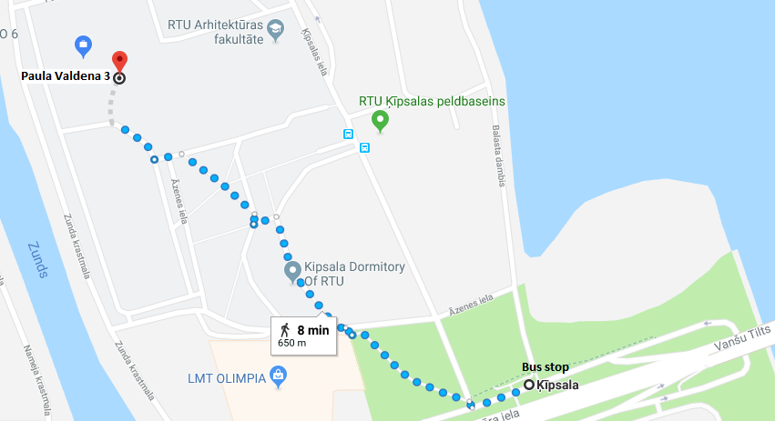
- Go through Island Square and past RTU Dormitory and the faculty (Venue) will be in front of You.

- From Riga International Airport by Bus No. 22., station "Kalnciema iela".
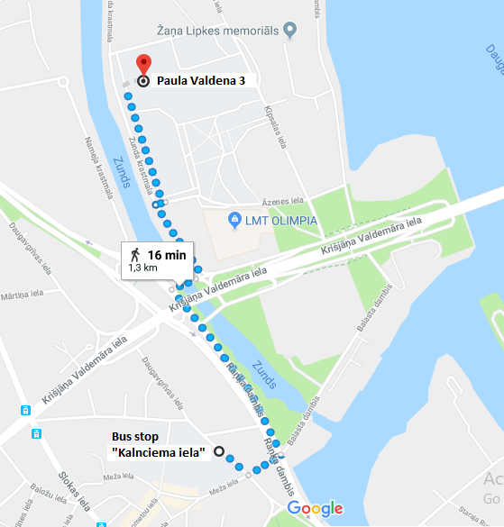
- After getting out cross the street and go left until You get to the channel. The turn left and follow it until You go under Vansu bridge and the cross it. The just keep following the channel until You reach the venue.
Events, sightseeing and information for tourists in Riga: LiveRiga https://www.liveriga.com/en/

